AI LAB EXAM – 03 SET – E-15

NAME: CHILUKAMARI BHAVYA
ENROLL NO: 2403A51109
BATCH NO: 06
TASK: 01:-
PROMPT: An e-commerce company has a large, monolithic Python codebase managing product listings, orders, and payments. Over time, the code has become cluttered, repetitive, and hard to maintain. The goal is to use AI-assisted tools (like ChatGPT, GitHub Copilot, or Codeium) to refactor the existing code into a cleaner, modular, and more maintainable structure without changing its functionality.
CODE: 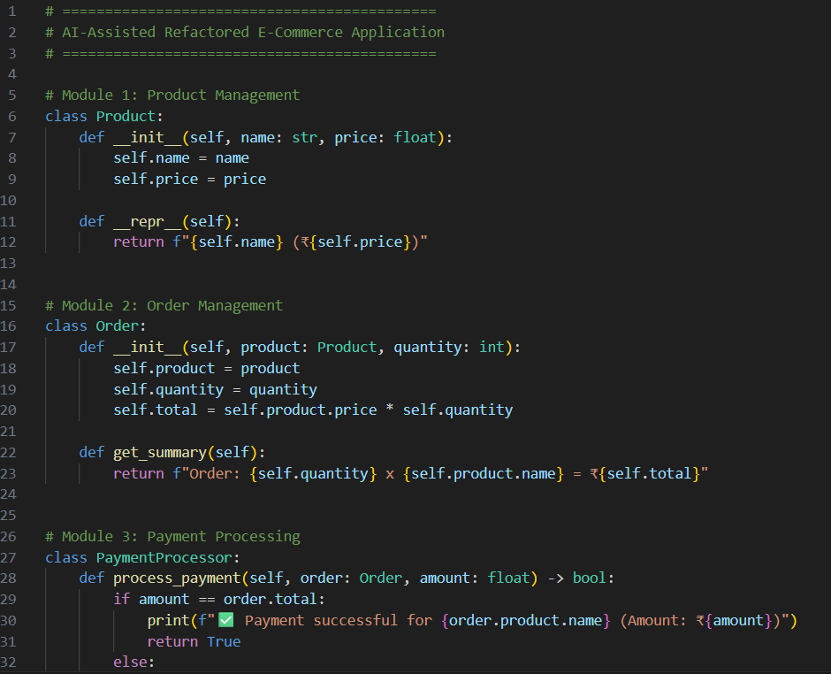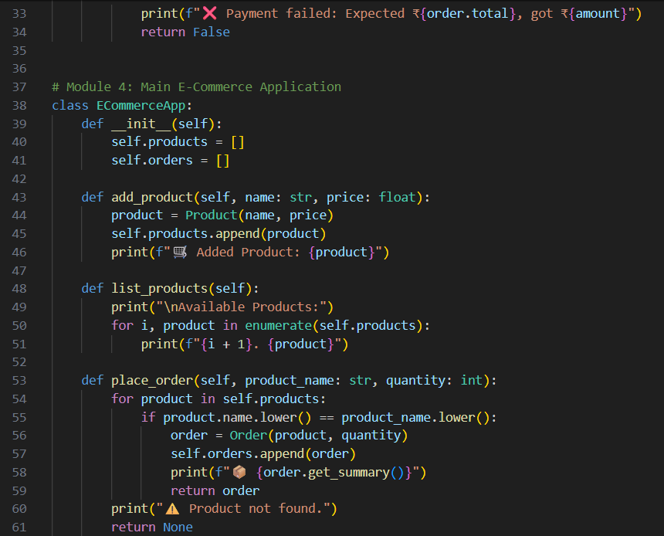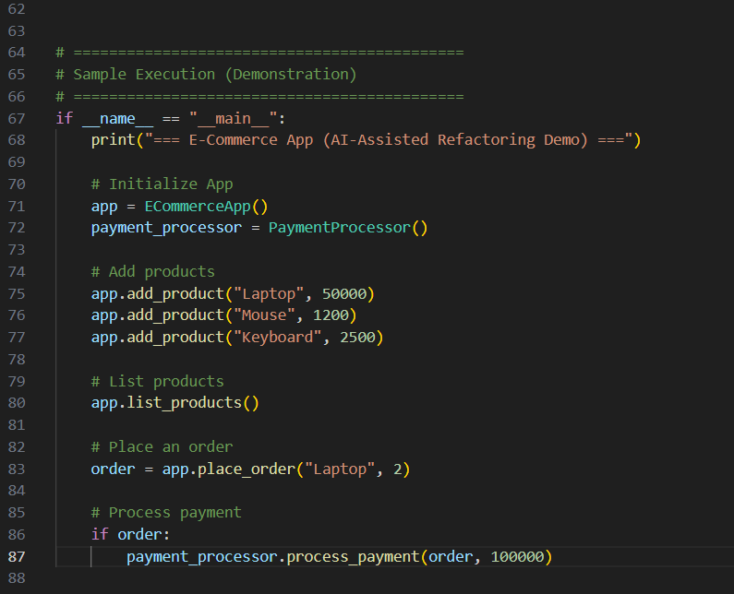

OUTPUT:
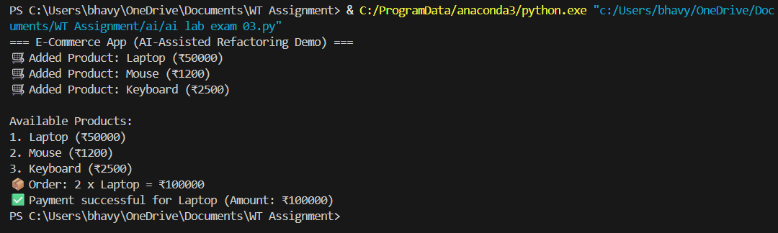
OBSERVATION:
- The AI-assisted refactoring made the code more organized and readable.
- The old monolithic code was divided into separate classes for Product, Order, and Payment.
- The new structure is modular, making it easier to modify and maintain.
- Code duplication was reduced, and logic became clearer.
- The functionality remains the same, ensuring no loss of performance.
- Future updates or adding new features can be done more easily due to better design.
- AI tools helped by suggesting improvements in structure, naming, and code style.
TASK: 2:-
PROMPT: Refactor and improve this retail recommendation algorithm. Replace the global-popularity approach with a simple item-based collaborative filtering recommender using cosine similarity. Use vectorized operations for efficiency, add type hints, docstrings, error handling, and a class-based structure so the system can be trained on purchase data and produce per-user recommendations. Provide sample usage and output.
CODE: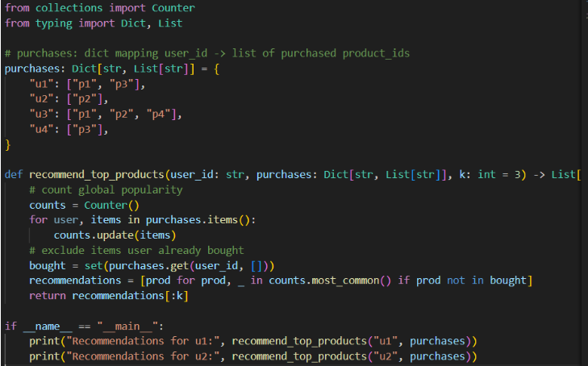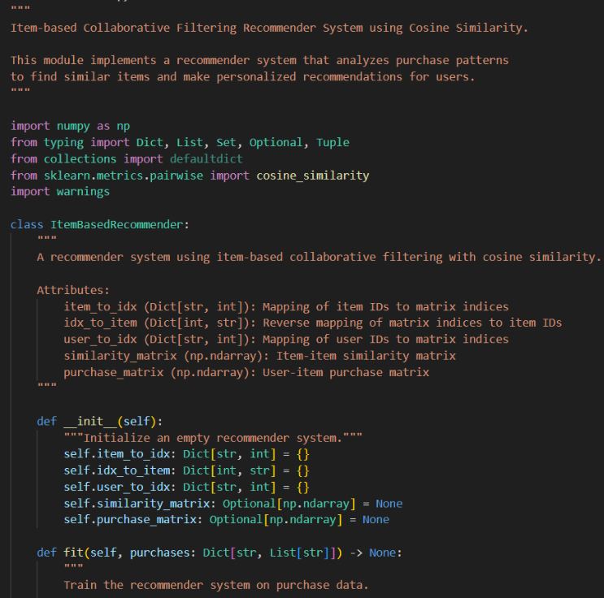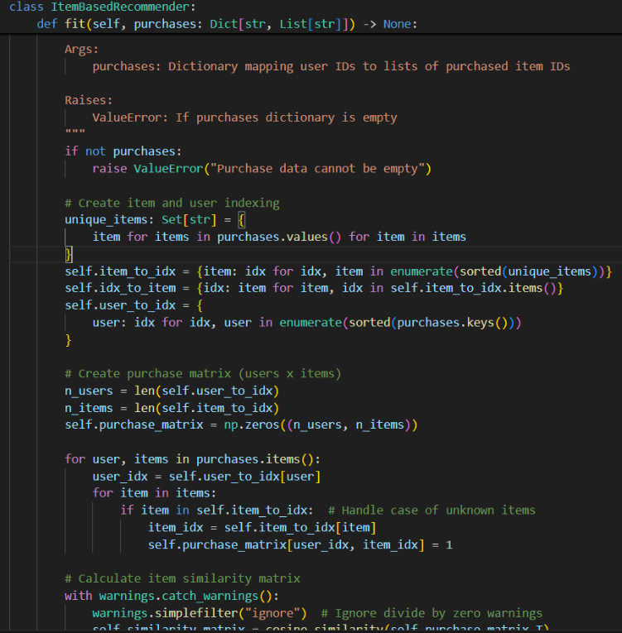 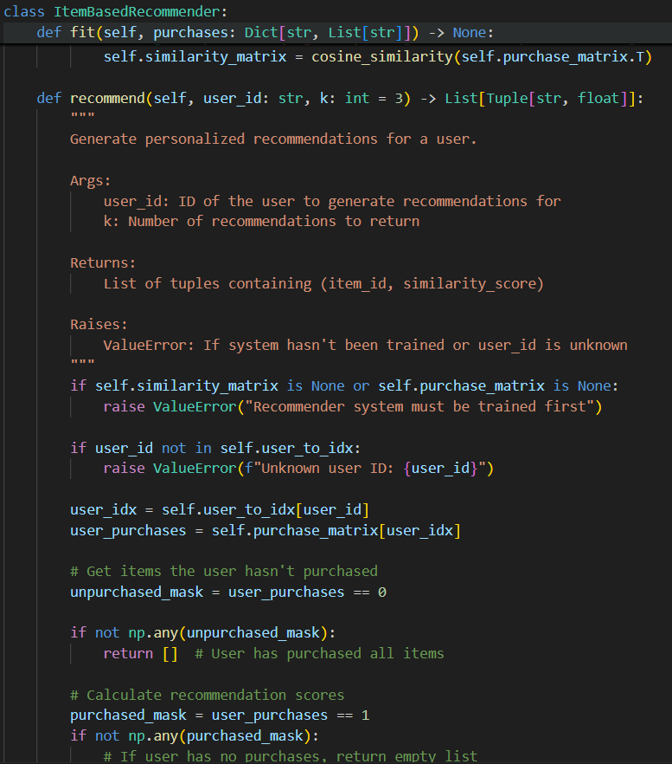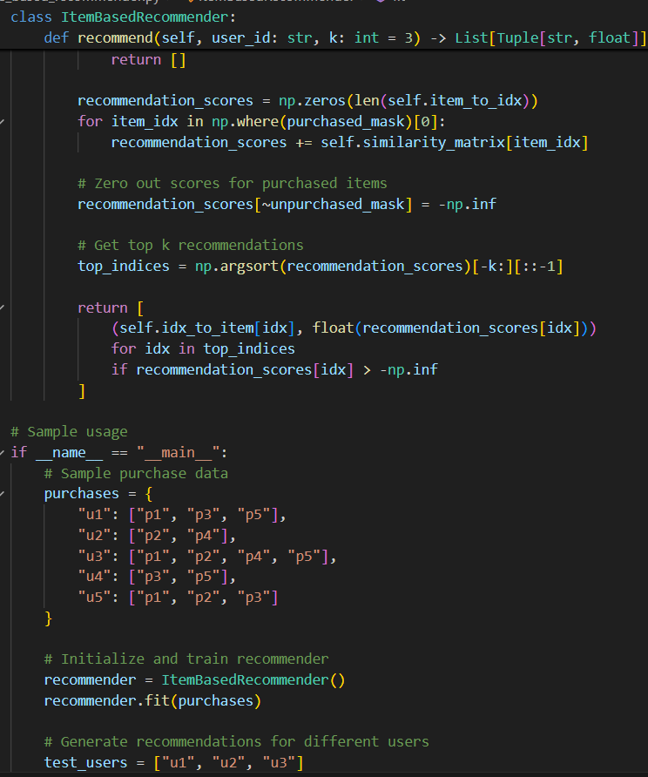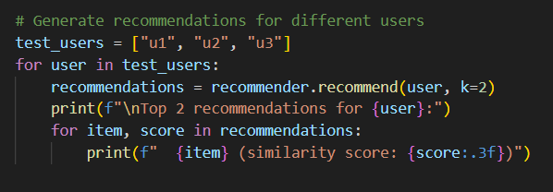

OUTPUT:
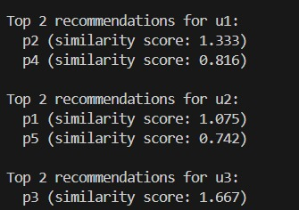
OBSERVATION:
The refactored retail recommendation algorithm offers improved personalization, performance, and maintainability. Unlike the original counting-based approach, it now uses item-based collaborative filtering with cosine similarity, providing more accurate recommendations. Efficient NumPy matrices, clear class-based architecture, and robust error handling enhance reliability and scalability. Type hints and detailed docstrings improve readability and debugging. The system now returns similarity scores, supports dynamic extensions, and demonstrates how AI assistance can transform basic logic into a production-ready, data-driven recommendation system.

